**Lab 5: Web_API_HandsOn**

**Code:**

**Program.cs**

using Microsoft.AspNetCore.Authentication.JwtBearer;

using Microsoft.IdentityModel.Tokens;

using System.Text;

var builder = WebApplication.CreateBuilder(args);

string securityKey = "mysuperdupersecretkey@1234567890!"; // At least 32 characters

var symmetricSecurityKey = new SymmetricSecurityKey(Encoding.UTF8.GetBytes(securityKey));

// Configure JWT Authentication

builder.Services.AddAuthentication(options =>

{

options.DefaultAuthenticateScheme = JwtBearerDefaults.AuthenticationScheme;

options.DefaultChallengeScheme = JwtBearerDefaults.AuthenticationScheme;

options.DefaultScheme = JwtBearerDefaults.AuthenticationScheme;

})

.AddJwtBearer(JwtBearerDefaults.AuthenticationScheme, options =>

{

options.TokenValidationParameters = new TokenValidationParameters

{

ValidateIssuer = true,

ValidateAudience = true,

ValidateLifetime = true,

ValidateIssuerSigningKey = true,

ValidIssuer = "mySystem",

ValidAudience = "myUsers",

IssuerSigningKey = symmetricSecurityKey

};

});

// Enable CORS

builder.Services.AddCors(options =>

{

options.AddPolicy("AllowAll", policy =>

{

policy.AllowAnyOrigin()

.AllowAnyMethod()

.AllowAnyHeader();

});

});

// Add Controllers and Swagger

builder.Services.AddControllers();

builder.Services.AddEndpointsApiExplorer();

builder.Services.AddSwaggerGen();

var app = builder.Build();

// Enable middleware

app.UseCors("AllowAll");

if (app.Environment.IsDevelopment())

{

app.UseSwagger();

app.UseSwaggerUI();

}

app.UseHttpsRedirection();

app.UseAuthentication(); // Must come before UseAuthorization

app.UseAuthorization();

app.MapControllers();

app.Run();

**AuthController.cs**

using Microsoft.AspNetCore.Authorization;

using Microsoft.AspNetCore.Mvc;

using Microsoft.IdentityModel.Tokens;

using System.IdentityModel.Tokens.Jwt;

using System.Security.Claims;

using System.Text;

namespace SecureEmployeeAPI.Controllers

{

[AllowAnonymous] // ✅ Allows unauthenticated access

[ApiController]

[Route("api/[controller]")]

public class AuthController : ControllerBase

{

[HttpGet("token")]

public IActionResult GetToken()

{

var token = GenerateJSONWebToken(101, "Admin"); // Hardcoded user ID & role

return Ok(new { Token = token });

}

private string GenerateJSONWebToken(int userId, string userRole)

{

var securityKey = new SymmetricSecurityKey(Encoding.UTF8.GetBytes("mysuperdupersecretkey@1234567890!"));

var credentials = new SigningCredentials(securityKey, SecurityAlgorithms.HmacSha256);

var claims = new List<Claim>

{

new Claim(ClaimTypes.Role, userRole),

new Claim("UserId", userId.ToString())

};

var token = new JwtSecurityToken(

issuer: "mySystem",

audience: "myUsers",

claims: claims,

expires: DateTime.Now.AddMinutes(10), // Token expires in 10 min

signingCredentials: credentials);

return new JwtSecurityTokenHandler().WriteToken(token);

}

}

}

**Snapshot:**

**JWT Token Access Screenshot:**

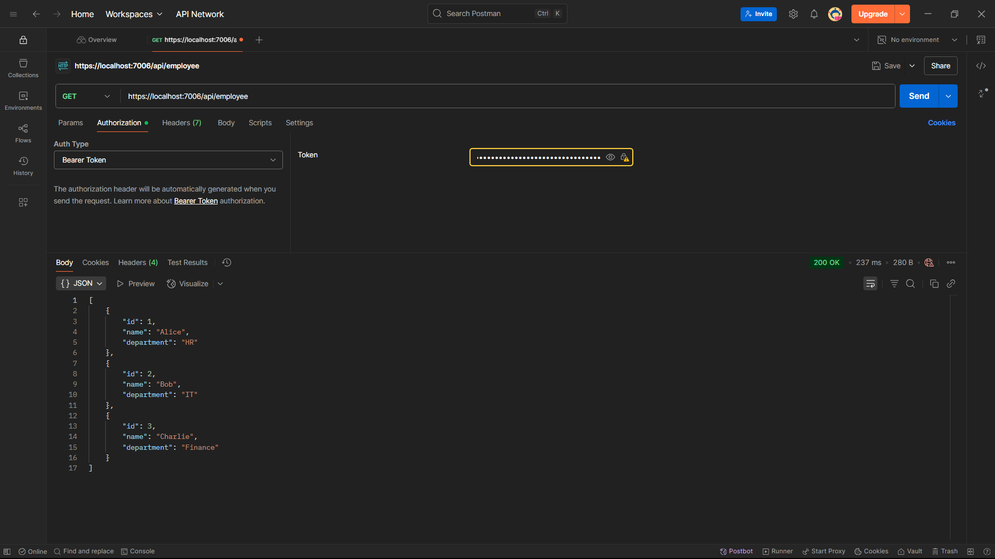

**Final Output:**

    {

        "id": 1,

        "name": "Alice",

        "department": "HR"

    },

    {

        "id": 2,

        "name": "Bob",

        "department": "IT"

    },

    {

        "id": 3,

        "name": "Charlie",

        "department": "Finance"

    }

]